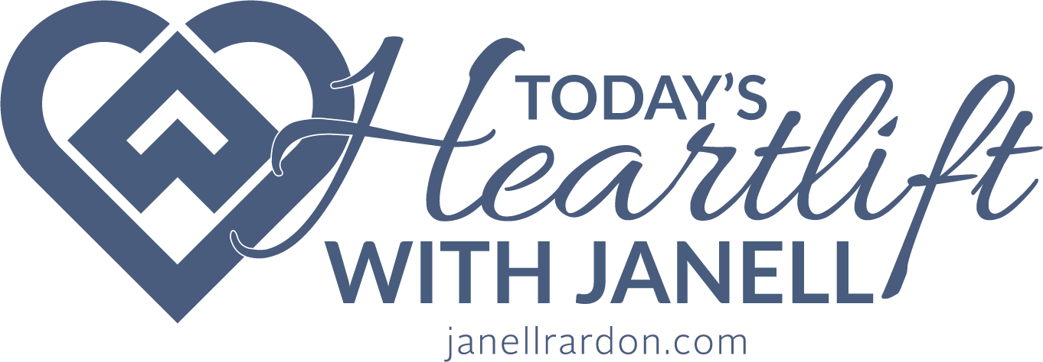

Podcast Guest: Caroline Williams

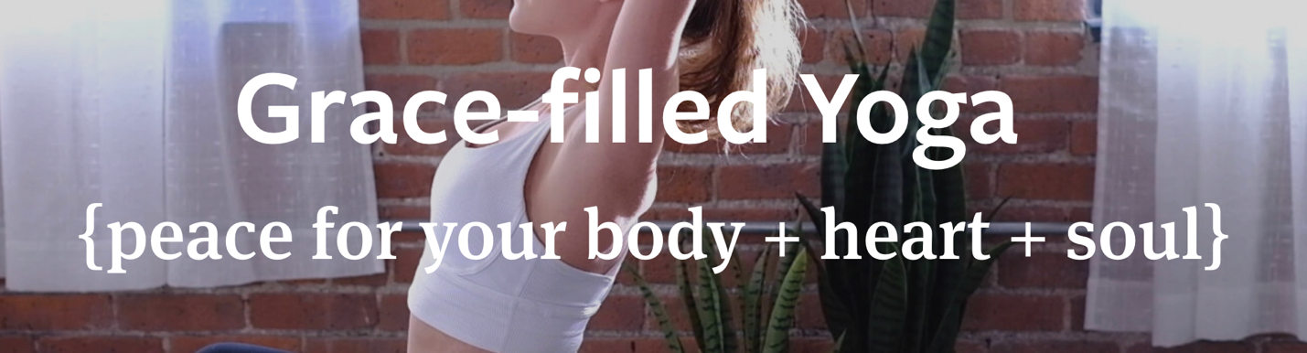

Working Podcast Theme: Becoming Stronger Every Day Through Yoga

Opening of Podcast: Read this as the pull quote (either Janell or Caroline):

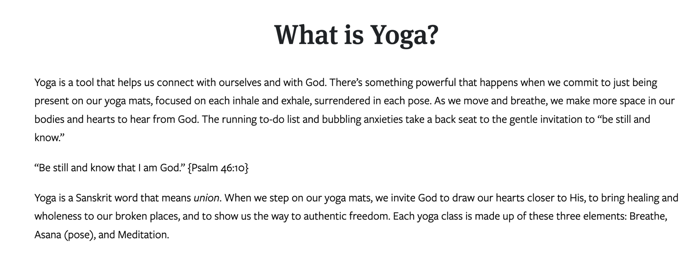

Introduce Caroline

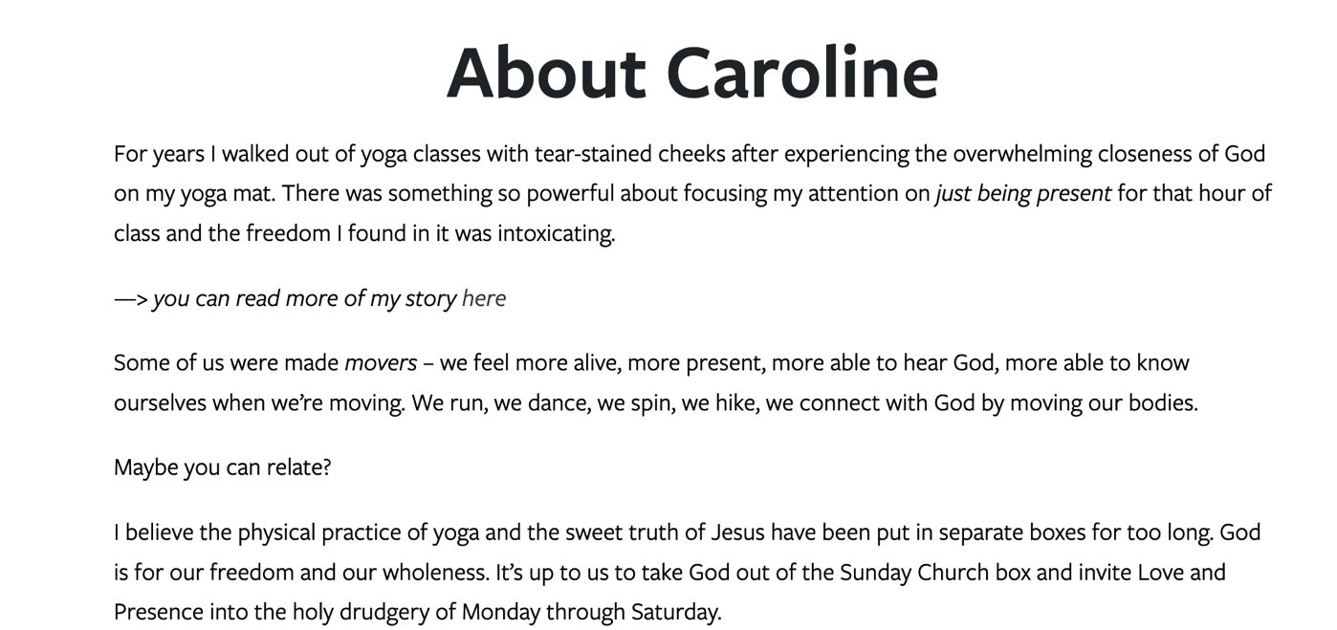

MORE ABOUT Caroline’s Yoga Training
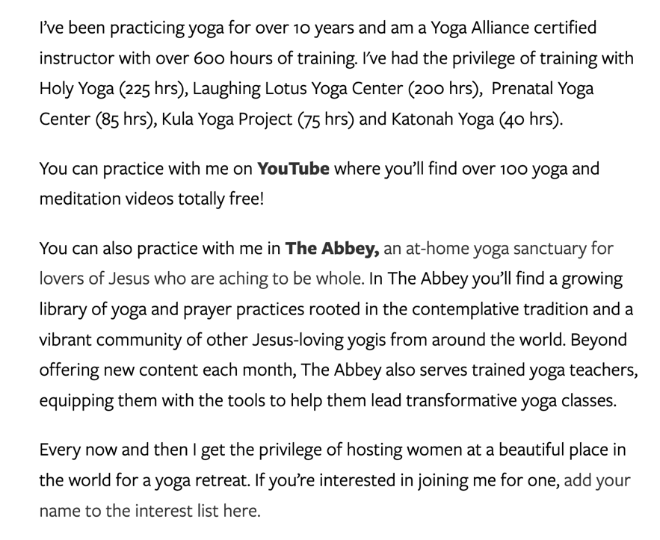

Possible Directives and Questions:

- On your website, you tell your story, “Yoga + Christianity, My Story.” I cried when I read the first line, “I found yoga through heartbreak.” Can you share more?
- I’d like to zone in on the other sentence that took my breath away: “Every day that summer I walked down the hill from my house to the yoga studio and sweat and cried and let myself be loved back to wholeness by a God, I’d distanced myself from.”
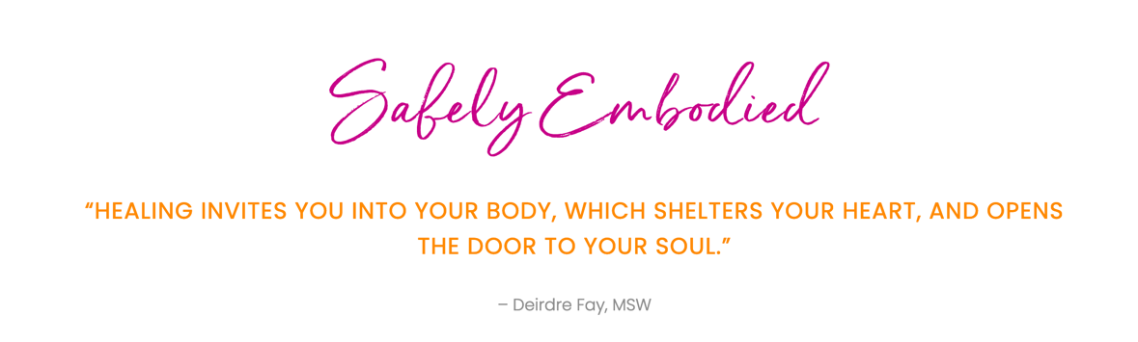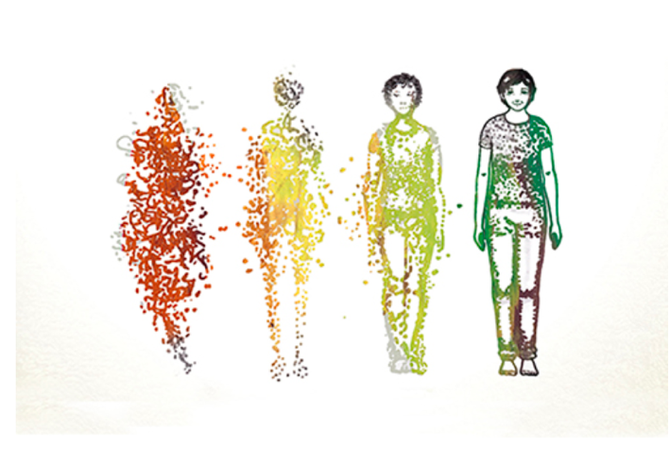
  - As a trauma-informed therapist, I wonder if you weren’t really “distanced from yourself,”—which we call “disembodiment,” and the practice of yoga led you “back to yourself,”—which we call “embodiment.” Can you share your thoughts on this? In my own emotional healing, that is what YOGA did for me—YET it also invited “shaming” and “judgement” and “suspicion” from my fellow Christian “leaders.” You shouldn’t be inviting that into your life. It is evil.
  - Help “us,” i.e., followers of Jesus, with this “misunderstanding” or “misalignment” of the practice of yoga.
- You share, “Yoga and I reconnected again a few years later, this time over being heart broken by disappointment and a deep feeling of failure when the career path I’d chosen was making me miserable. I faithfully went to church, read all the books, and filled journals with my longing cry for God to open a new career door, and tell me who I was and what I was meant to do with my life. All I heard was a lot of silence. That is, until I hit my mat.” WOW.
  - You literally took the words out of my mouth, “I always wondered—how could I hear God so powerfully and intimately in a yoga studio playing rap music with statues of Ganesh everywhere and an instructor who chanted things in a different language?” PLEASE, tell us more.
- I absolutely love your at-home yoga sanctuary, “The Abbey,” https://www.theyogaabbey.com/, and would love for you to share “how” and “why” and all the things about bringing this vision to life.

Possible Closure.

Caroline, if you would, do you have a meditation you could lead us through here at the end? And in doing so, maybe enlarge our understanding of the role of meditation in our daily life?

From Caroline’s writings on the history of YOGA:

